**DeVry University**

**CIS336 Introduction to Database with MySQL**

**May 18, 2016**

**Unit-3 Lab**

**Nathan Rivera**

**STEP 1: The DROP Statements**

I’m not sure if you want a screenshot or a list of code so here is both

set foreign_key_checks = 0;

drop table if exists ZIPCODE;

drop table if exists INSTRUCTOR;

drop table if exists STUDENT;

drop table if exists COURSE;

drop table if exists SECTION;

drop table if exists ENROLLMENT;

set foreign_key_checks = 1;

**STEP 2: The CREATE TABLE Statements**

create table ZIPCODE

(

Zip integer (11),

City VARCHAR (25) NOT NULL,

State CHAR (2) NOT NULL,

constraint pk_zip primary key (Zip)

);

create table INSTRUCTOR

(

Instructor_ID integer(6),

Salutation varchar(5),

First_Name varchar(25) not null,

Last_Name varchar(25) not null,

Street_Address varchar(50),

Zip integer(11) not null,

constraint pk_instructor_id primary key (Instructor_ID)

);

create table STUDENT

(

Student_ID integer(6),

Salutation varchar(5),

First_Name varchar(25) not null,

Last_Name varchar(25) not null,

Street_Address varchar(50),

Zip integer(11) not null,

Phone varchar(15) not null,

Employer varchar(50),

Registration_Date date not null,

constraint pk_student_id primary key (Student_ID)

);

create table COURSE

(

Course_ID integer(6),

Description varchar(50) not null,

Cost decimal(8,2),

-- on the Data Dictionary it says that Prerequisite is a FK however there are no other tables that have this entry so i cannot create a FK for or from it

Prerequisite integer(6),

constraint pk_course_id primary key (Course_ID)

);

create table SECTION

(

Section_ID integer(8),

Course_Section_Name integer(6) not null,

Start_Date_Time datetime not null,

Location varchar(10),

Capacity integer(3),

Instructor_ID integer(6) not null,

Course_ID integer(6) not null,

constraint pk_section_id primary key (Section_ID)

);

create table ENROLLMENT

(

Section_ID integer(8),

Student_ID integer(6),

Enroll_Date date not null,

Final_Grade char(1),

constraint pk_section_id_enrollment primary key (Section_ID, Student_ID)

);

alter table INSTRUCTOR add constraint fk_zip_instructor foreign key (Zip) references ZIPCODE (Zip);

alter table STUDENT add constraint fk_zip_student foreign key (Zip) references ZIPCODE (Zip);

alter table SECTION add constraint fk_instructor_id_section foreign key (Instructor_ID) references INSTRUCTOR (Instructor_ID);

alter table SECTION add constraint fk_course_id_section foreign key (Course_ID) references COURSE (Course_ID);

alter table ENROLLMENT add constraint fk_section_id_enrollment foreign key (Section_ID) references SECTION (Section_ID);

**STEP 3: The INSERT Statements for the Data**

**insert into ZIPCODE (Zip,City,State)**

**values**

**(7024,"Ft. Lee","NJ"),**

**(7047,"North Bergen","NJ"),**

**(10005,"New York","NY"),**

**(10015,"New York","NY"),**

**(10025,"New York","NY"),**

**(10035,"New York","NY"),**

**(11419,"Richmond Hill","NY"),**

**(11435,"Jamaica","NY");**

**insert into STUDENT (Student_ID, Salutation, First_Name, Last_Name, Street_Address, Phone, Employer, Registration_Date, Zip)**

**values**

**(102,"Mr.","Fred","Crocitto","101-09 120th St.",718-555-5555,"Albert Hildegard Co.",1/22/2007,11419),**

**(103,"Ms.","J.","Landry","7435 Boulevard East #45",201-555-5555,"Albert Hildegard Co.",1/22/2007,7047),**

**(104,"Ms.","Laetia","Enison","144-61 87th Ave",718-555-5555,"Albert Hildegard Co.",1/22/2007,11435),**

**(105,"Mr.","Angel","Moskowitz","320 John St.",201-555-5555,"Alex. & Alexander",1/22/2007,7024),**

**(163,"Ms.","Nicole","Gillen","4301 N Ocean #103",904-555-5555,"Oil of America Corp.",2/2/2007,10025),**

**(223,"Mr.","Frank","Pace","13 Burlington Dr.",203-555-5555,"Board Utilities",2/8/2007,10025),**

**(399,"Mr.","Jerry","Abdou","460 15th St. #4",718-555-5555,"Health Mgmt.Systems",2/23/2007,10025);**

**insert into INSTRUCTOR (Instructor_ID, Salutation, First_Name, Last_Name, Street_Address, Zip)**

**values**

**(101,"Mr","Fernand","Hanks","100 East 87th",10015),**

**(102,"Mr","Tom","Wojick","518 West 120th",10025),**

**(103,"Ms","Nina","Schorin","210 West 101st",10025),**

**(104,"Mr","Gary","Pertez","34 Sixth Ave",10035),**

**(105,"Ms","Anita","Morris","34 Maiden Lane",10015),**

**(106,"Rev","Todd","Smythe","210 West 101st",10025),**

**(107,"Dr","Marilyn","Frantzen","254 Bleeker",10005);**

**insert into COURSE (Course_ID,Description,Cost,Prerequisite)**

**values**

**(330,"Network Administration",1195,130),**

**(310,"Operating Systems",1195,NULL),**

**(142,"Project Management",1195,20),**

**(140,"Systems Analysis",1195,20),**

**(130,"Intro to Unix",1195,310),**

**(25,"Intro to Programming",1195,140),**

**(20,"Intro to Information Systems",1195,NULL);**

**insert into ENROLLMENT (Student_ID,Section_ID,Enroll_Date,Final_Grade)**

**value**

**(102,86,1/30/2007,"B"),**

**(102,89,1/30/2007,"A"),**

**(103,81,1/30/2007,NULL),**

**(104,81,1/30/2007,"A"),**

**(163,92,2/10/2007,NULL),**

**(223,104,2/16/2007,"C"),**

**(223,119,2/16/2007,NULL);**

**insert into SECTION (Section_ID,Course_ID,Course_Section_Name,Start_Date_Time,Location,Instructor_ID,Capacity)**

**values**

**(81,20,2,"2007-7-24 9:30:00","L210",103,15),**

**(86,25,2,"2007-6-10 9:30:00","L210",107,15),**

**(89,25,5,"2007-5-15 9:30:00","L509",103,25),**

**(92,25,8,"2007-6-13 9:30:00","L509",106,25),**

**(104,330,1,"2007-7-14 10:30:00","L511",104,25),**

**(119,142,1,"2007-7-14 9:30:00","L211",103,25),**

**(155,122,4,"2007-5-4 9:30:00","L210",107,15);**

**STEP 4: The SELECT Statements**

Select * from ZIPCODE;

Select * from INSTRUCTOR;

select * from STUDENT;

select * from COURSE;

Select * from SECTION;

Select * from Enrollment;

**STEP 5: Testing and Verifying Your Script**

***(Include print screen shots for each SELECT statement showing each of the SQL statements worked)***

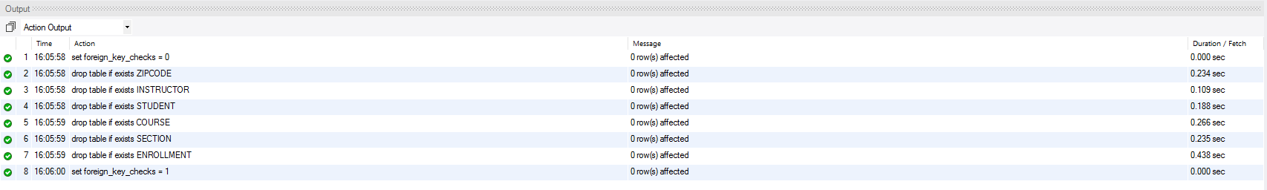

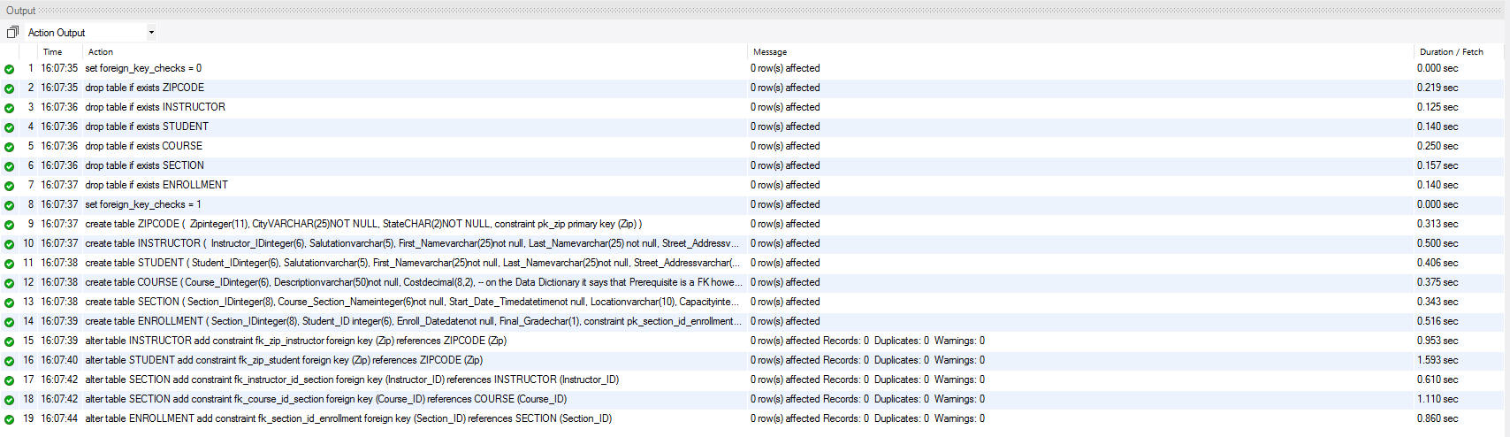

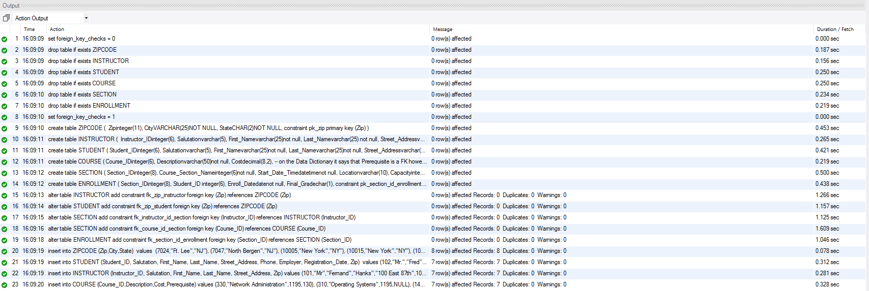

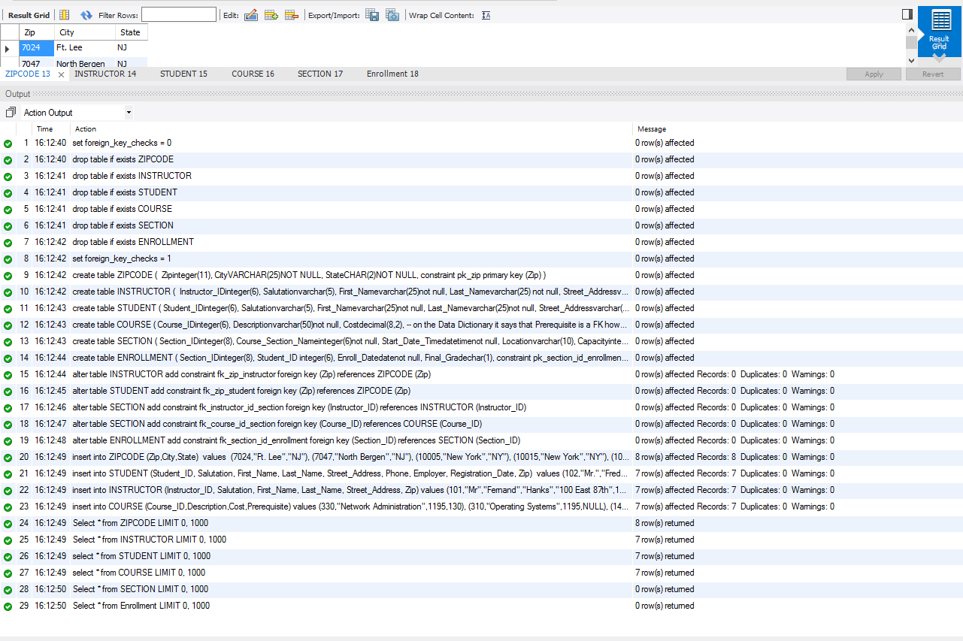

The select statements will only work if I leave out the previous insert statements mentioned

insert into ENROLLMENT (Student_ID,Section_ID,Enroll_Date,Final_Grade)

value

(102,86,1/30/2007,"B"),

(102,89,1/30/2007,"A"),

(103,81,1/30/2007,NULL),

(104,81,1/30/2007,"A"),

(163,92,2/10/2007,NULL),

(223,104,2/16/2007,"C"),

(223,119,2/16/2007,NULL);

insert into SECTION (Section_ID,Course_ID,Course_Section_Name,Start_Date_Time,Location,Instructor_ID,Capacity)

values

(81,20,2,"2007-7-24 9:30:00","L210",103,15),

(86,25,2,"2007-6-10 9:30:00","L210",107,15),

(89,25,5,"2007-5-15 9:30:00","L509",103,25),

(92,25,8,"2007-6-13 9:30:00","L509",106,25),

(104,330,1,"2007-7-14 10:30:00","L511",104,25),

(119,142,1,"2007-7-14 9:30:00","L211",103,25),

(155,122,4,"2007-5-4 9:30:00","L210",107,15);

As of yet I have not workarounds in how im supposed to solve this issue

Ive had a number of issues with the insert statement. It only works if I do not enter the insert statements as followed

insert into ENROLLMENT (Student_ID,Section_ID,Enroll_Date,Final_Grade)

value

(102,86,1/30/2007,"B"),

(102,89,1/30/2007,"A"),

(103,81,1/30/2007,NULL),

(104,81,1/30/2007,"A"),

(163,92,2/10/2007,NULL),

(223,104,2/16/2007,"C"),

(223,119,2/16/2007,NULL);

insert into SECTION (Section_ID,Course_ID,Course_Section_Name,Start_Date_Time,Location,Instructor_ID,Capacity)

values

(81,20,2,"2007-7-24 9:30:00","L210",103,15),

(86,25,2,"2007-6-10 9:30:00","L210",107,15),

(89,25,5,"2007-5-15 9:30:00","L509",103,25),

(92,25,8,"2007-6-13 9:30:00","L509",106,25),

(104,330,1,"2007-7-14 10:30:00","L511",104,25),

(119,142,1,"2007-7-14 9:30:00","L211",103,25),

(155,122,4,"2007-5-4 9:30:00","L210",107,15);

If I leave them in I get this error

full error: SQL Cannot add or update a child row: a foreign key constraint fails (wk3_lab.section, CONSTRAINT fk_course_id_section FOREIGN KEY (Course_ID) REFERENCES course(Course_ID))

ive tried everything to avail no matter what I do I will get an error.